To: | City Executive Board
Date: | 15 December 2016
Report of: | Head of Financial Services
Title of Report: | Treasury Management Performance report for the six months ending 30 September 2016

Summary and recommendations
Purpose of report: |  | To report on the performance of the treasury management function for the 6 months to 30 September 2016.
Key decision: |  | No
Executive Board Member: |  | Cllr Ed Turner, Finance, Asset Management and Public Health
Corporate Priority: |  | None
Policy Framework: |  | Efficient and effective Council
Recommendation: That the City Executive Board resolves to:
1. | Note the performance of the treasury management function for the six months to 30 September 2016

Appendices
Appendix 1 | List of investments as at 30 September 2016
Appendix 2 | Risk Register

Introduction and background
- In its Code of Practice on Treasury Management, the Chartered Institute of Public Finance and Accountancy (CIPFA) requires that the Council receives an update report on its Treasury Management activities at least twice a year; this report provides members with an overview of Treasury Management performance for the first half of the 2016/17 financial year.

Economic Overview
Prior to the referendum UK economic growth slowed in the first two quarters of 2016 and forecasts for the remainder of 2016 have been reduced down. In response, the Bank of England’s Monetary Policy Committee (MPC) cut the Bank Rate from 0.50% to 0.25%. The Consumer Price Index (CPI) has started rising and forecasts indicate it will reach 3% over a time period of 3-4 years arising from increases in the cost of imports. It will be interesting to see if the Chancellor’s post Brexit announcement that the target of achieving a budget surplus in 2020 will be eased in the Autumn Statement comes to fruition.

Investment Performance 2016/17
The performance target for treasury investments is 0.5% above base rate. The target therefore was 1% at the start of the financial year. With the reduction in the base rate, the target will now be lower than 1% over the whole financial year. The cumulative average rate of return on investments to 30 September 2016 was 1.07%, which is 0.07% above the starting performance target of 1%. The primary reason for the Council’s return being above target is due to its investment in property funds and it is important to note that without these, the return would fall below target due to longer term investments reaching maturity and being reinvested at lower rates following the base rate cut. A forecasted further cut to bank base rates will only worsen investment returns.
The budgeted investment income for 2016/17 is £0.746 million. As at the 30 September 2016, forecast investment income is £0.925m (an overachievement of £0.179 million). Income received to 30 September is £0.254 million.
To date between £10 million and £25 million has been held in money market funds, averaging an annual interest rate of 0.44%. Whilst interest rates have fallen across all types of investment; money market funds have continued to offer competitive rates with the added benefit of liquidity and security. Further investment is planned in cash plus funds which offer improved rates with slightly less liquidity. This should result in increased rates being achieved in this type of investment in the second half of the financial year compared to alternative investments.
The Council’s investment balances have gradually increased as the financial year has progressed. Average cash balances in the year to 31 March 2016 were £74.8m and this figure has steadily risen month on month. As at 30 September 2016, the Council’s total investments amounted to £81m. This is the usual position for the time of year as cash income exceeds expenditure (due to grant receipts, business income etc.); however, investment balances are expected to decrease towards the end of the financial year when less income is collected.
The Council has a range of investment types (i.e. fixed deposits, notice accounts, externally managed property funds, call accounts and money market funds) which are deposited across different counterparties including banks, building societies and Local Authorities. The chart below shows the distribution of the Council’s Investment Portfolio as at 30 September 2016:
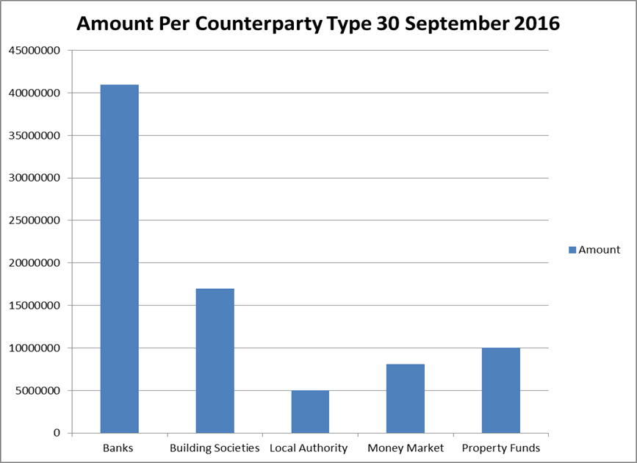
The Council’s Treasury Management Strategy limits non-specified investments (which include property fund and local authority investments of over 364 days) to 25% of the previous year’s average investment portfolio. This limit is decided on each year when setting the Strategy in order to ensure a balanced portfolio of investments. For 2016/17, the limit for non-specified investments is around £18 million and this amount has largely been committed with £10 million in CCLA and Lothbury and £5 million in the National Homelessness Property Fund (Real Lettings). From 2017/18 onwards, it is anticipated the Council will undertake significant capital expenditure in relation to the Council’s housing company, some of which will be funded from internal borrowing. This will reduce the level of cash resources available for investment and hence the overall investment portfolio. The Council will still need to maintain a high level of liquid resources to meet its obligations; based on 2015/16 figures the Council needs to maintain at least £19 million liquid resources on average. Maintaining the necessary level of liquid resources together with the requirement to maintain a balanced portfolio means that the Council cannot undertake any additional long term investments, e.g. property funds.
The graph below compares the Council’s in-house average rate of return for each month to the Bank of England’s Base Rate and the benchmark interest rates:
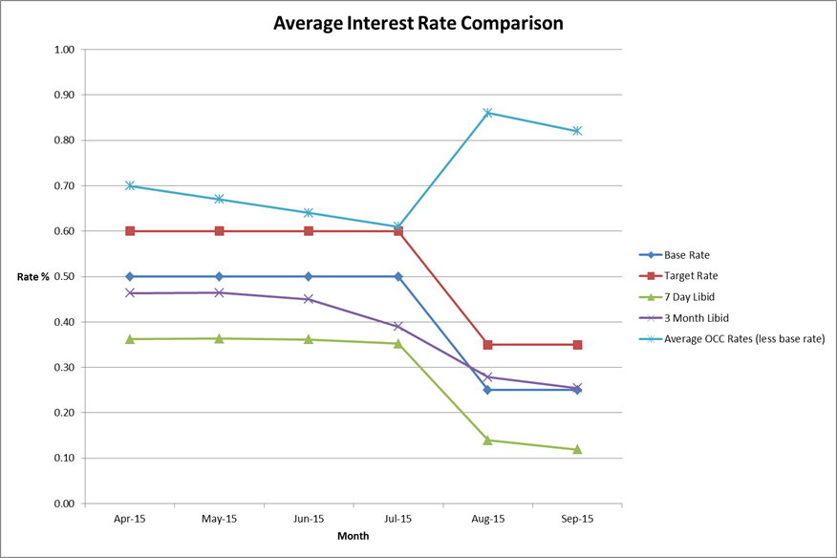
The graph shows that the Council has consistently performed above target for the first half of the financial year and it is believed that the rate of return will continue to be above target for the remainder of the year. Interest rates have dropped over the first two quarters of the year, initially because of referendum fears and then because of the result. The sudden increase in the average OCC rates in August reflects the fall of the base rate from 0.5% to 0.25%; however the total interest received has continued to fall as individual investments have come to an end. The current forecasts indicate that the Base Rate may fall to 0.10% in the first quarter of 2017.

Icelandic Investments
In October 2008, the Icelandic banks Landsbanki, Kaupthing and Glitnir collapsed and the UK subsidiaries of the banks, Heritable and Kaupthing Singer and Friedlander went into administration. The authority had £4.5 million deposits with Icelandic banks; £1.5m with Glitnir and £3m with Heritable (which formed part of the Landsbanki group). The Council has received the final payment in relation to the Glitnir investment which does not directly correlate with the outstanding balance due to exchange rate losses but as far as the Council is concerned, funds have now been fully recovered and the balance of £88,000 of the Glitnir investment will be written off. Heritable has repaid £2.94m plus interest to date, with the outstanding balance being £58,000.

Property Funds

CCLA Investment Management Limited
CCLA is a specialist investment management firm that acts on behalf of charities, faith organisations, and local authorities. The amount invested in the CCLA property fund was £3m (September 2013). The investment has produced quarterly returns ranging between 5% and 6% to date and it is expected that the fund will continue to achieve rates in this region. The impact of this return is illustrated in the average weighted monthly return shown in the interest graph at paragraph 9 above.
In addition to the interest earned from the CCLA property fund, the value of the Council’s investment has appreciated from £3m since inception to £3.6m as at 30 September 2016. Following the Brexit result Property Funds have suffered over the uncertainty of future economic growth and consequently the capital value has fallen £135,000 since April 2016.
The table below shows the gains and losses made on the fund each quarter this year (Plus the figures at 31 March 2015 in order to show the opening position) and also details the quarterly dividends received. The Council holds 1,273,612 units in the fund and the unit price is re-valued on a monthly basis, reflecting the current value of the investment (but not the interest).
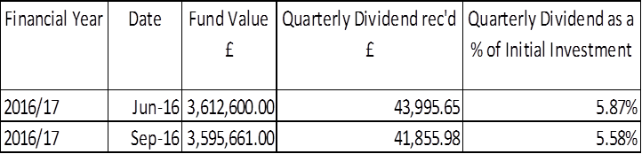

Lothbury Property Fund
During 2014/15, the Council invested £7m in the Lothbury Property fund and the fund has produced quarterly returns in the range of 3-4% to date
The table below shows the gains and losses made on the fund each quarter this year (Plus the figures at 31 March 2015 in order to show the opening position) and also details the quarterly dividends received. The Council holds 4,219 units in the fund and the unit price is re-valued on a monthly basis, reflecting the current value of the investment (but not the interest).
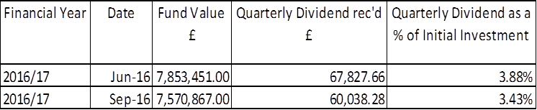
In addition to the interest earned from the Lothbury property fund, the actual principal value of the Council’s investment has increased from £7m since inception to £7.6m as at 30 September 2016. Like the CCLA fund highlighted above this fund has seen a fall in value since April of £127,000.

The Treasury Management Counterparty List
The approved counterparty list provides limits on the amount which can be invested in any one counterparty/counterparty group at a given point. It also confirms the maximum duration permitted per investment. The Council adheres to this listing to ensure it does not breach its Treasury Management Strategy. The list is updated on a weekly basis, sometimes more frequently if changes in the market dictate a more imminent review.
The Council’s approved counterparty list is based upon recommendations from Capita Asset Services although ultimate authorisation of which counterparties are approved rests with the Council’s S151 Officer. In essence, the approved counterparties are determined by credit ratings provided by the three main credit rating agencies and through the monitoring of counterparties’ credit default swap spreads.

Borrowing
The Council has not taken on any additional debt during the year to date and so the balance of its external borrowing remains at approximately £198.5 million as at 30 September 2016; this figure relates to funds borrowed from the Public Work Loans Board (PWLB) to buy out the Housing Revenue Account (HRA) from the subsidy system and relates wholly to Housing with interest repayment being met by the HRA. The Council does not consider that debt restructuring and/or premature repayment would be practical at this time as the Council would incur a large premium from the PWLB for doing so. The Council continues to monitor borrowing interest rates and forecasts on a regular basis and will keep its position on debt restructuring under review.
The Council anticipates borrowing in the future to meet its capital expenditure requirements, including loans to the Housing Company, but does not expect any external borrowing will be required in 2016/17.

Financial implications
- Financial implications are contained within the body of the report.

Legal issues
- There are no legal implications directly relevant to this report.

Level of risk
- There are no risks in connection with the report’s recommendations. Risk assessment and management is a key part of Treasury Management activity especially in the selection of counterparties when considering investment opportunities. The Council uses external advisors and counterparty credit ratings issued by the rating agencies to assist in this process.

Equalities impact
- There are no equalities impacts arising directly from this report.

Report author | Bill Lewis
Job title | Financial Accounting Manager
Service area or department | Financial Services
Telephone | 01865 252607
e-mail | blewis@oxford.gov.uk

Background Papers: None

